**Wireshark Lab 2 – HTTP**

1. Is your browser running HTTP version 1.0 or 1.1?



**Version- 1.1**



1. When was the HTML file that you are retrieving last modified at the server?

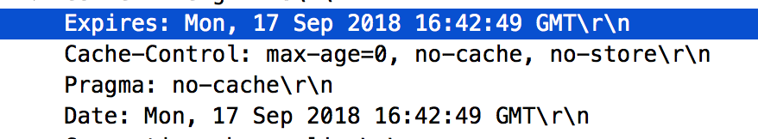

1. What is the IP address of your computer? Of the gaia.cs.umass.edu server? 

**Computer IP: 10.0.0.102**

**Server (Destination/ Client IP): 204.237.142.176**

1. What languages (if any) does your browser indicate that it can accept to the server?



**Language that it can accept to the server**

1. When was the HTML file that you are retrieving last modified at the server?

